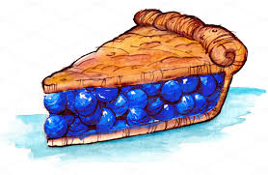
Borough of Sayreville’s
Pie Bake Off

Please review prior to Registration:

- Must be a Sayreville resident.
- Entry must be a fruit pie.
- List of Ingredients must be submitted by Sept. 29
- All components must be homemade-NO store bought dough or fillings.
- Pies must be cooked in a 9 in round disposable baking tin.
- Entries will be judged anonymously. Each pie will be assigned a number at drop-off.
- Pie must be able to be kept at room temperature or cold. NO warm pies.
- Pies must be dropped off at the Welcome Tent between 11:00am and 11:30am on Oct. 2
- The pies will be judged by the Mayor and Council using the following criteria:
- Appearance (10 Points)
- Overall Taste (10 Points)
- Filling Texture and Flavor (15 Points)
- Crust Texture and Flavor (15 Points)
- Creativity (5 Points)
- Aroma (5 Points)
- TOTAL POSSIBLE POINTS = 60
- Awards will be announced at 6:45pm on Oct. 2.
- Prizes will be given to First, Second and Third Place.

